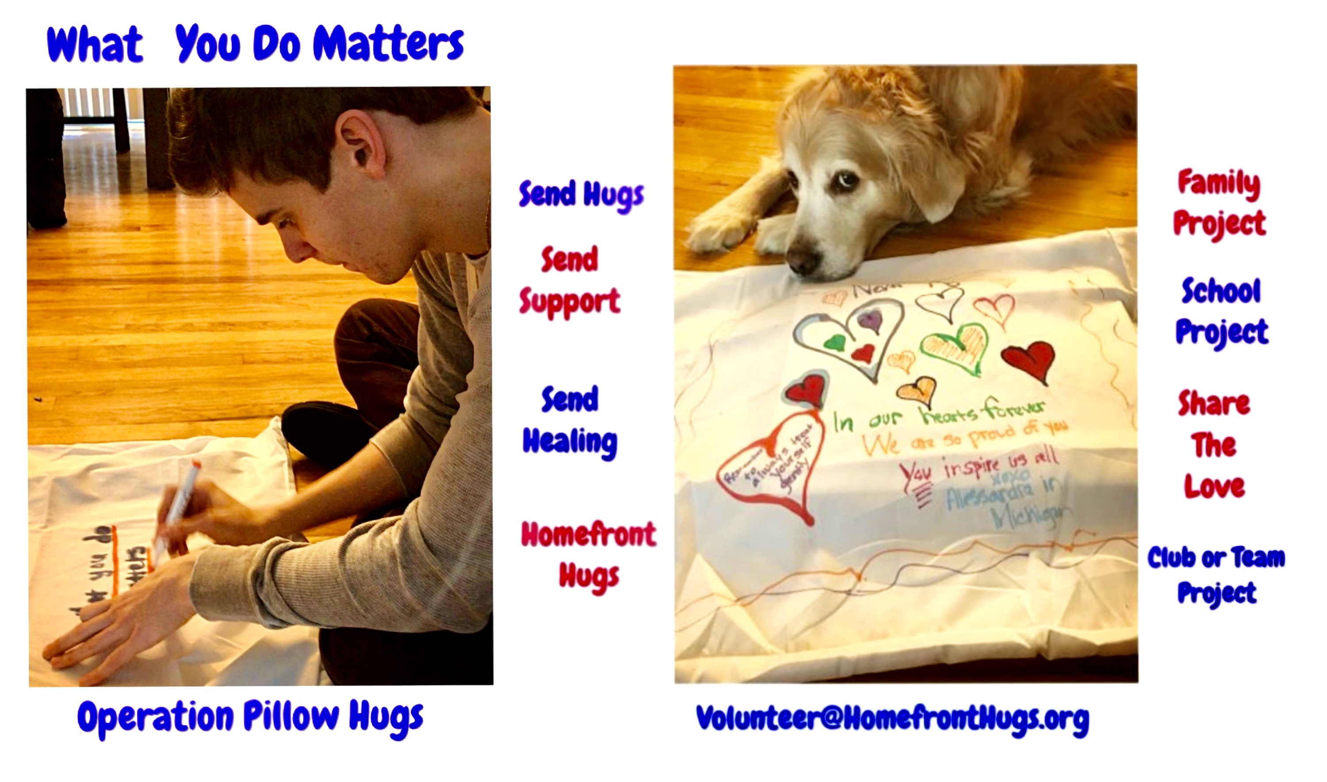
Operation Pillow Hugs
🔸Buy a light colored pillowcase and decorate one or two with permanent or fabric markers with some positive messages for a hospitalized, wounded or deployed veteran.

🔸To decorate a pillowcase, have a piece of cardboard inside the pillowcase so your work does not stain through to the other side and you can decorate on both sides. Fabric markers work best but permanent markers work too.

🔸Add your first name and age and state (and school or group if you want) on the pillowcase ...after decorating and adding any positive messages like “ Get Well Soon”, “ Always in our hearts”, “ Stay Strong”, “ Keep Smiling “, “ A Hero Sleeps here “, “ Heroes Rock “, “God bless the USA”, “ Thank You “,anything you can think of to make this feel like a Homefront Hug!

🔸Deadline: None! We love these all year round!

🔶Address:
Homefront Hugs Foundation
Operation Pillow Hugs
314 Goodmans Crossing
Clark,NJ 07066

Ps. We appreciate any donation to help with postage to mail these on to hospitalized and deployed veterans. And we also love photos of artists holding up their pillowcases they made so please email them to Volunteer@HomefrontHugs.org so we can share them with our heroes!

