HOLIDAY STOCKINGS FOR OUR VETERANS IN THE VA HOSPITAL- OPERATION HEALING ANGEL
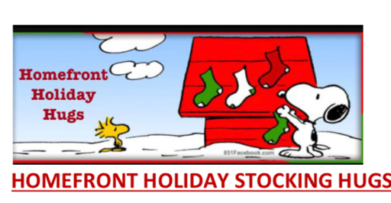

Suggestions of items to include:
️ Mini calendar of nature, animals, aviation, ships, Garfield or spiritual sayings
️ letter or card from you handwritten sharing a little about you even with photo of you or group
️ sugar free peppermint Patties or anything sugar free including cookies
️ comfy socks with tread sizes 9-12
️ playing cards large print if possible
️ pen & small blank journal
️ hand lotion light or no scent
️ lip balm for dry lips like Chapstick or Burt’s Bees
️ handmade art and drawings for their walls
️ warm cozy soft scarf
️ sudoku large print
️ soft travel tissues
️ any flameless candle or LED lights to brighten room
️ large print magazine like Readers Digest or any magazine
️ stamped postcard with your address if you wish to hear back
️ small nerf ball for inside
️ disposable mask w/ Camo print or US flag
️ decorated pillowcase with positive messages (Operation Pillow Hugs flyer under Forms)

✅Hint:
• You can actually use the pillows you decorated as your “ stockings “
• You do not have to choose all of the above – choose what you can do and ideas of your own too!
• Handwritten letters can be on copy paper that you copied a photo of your group or family on as a header or footer then start your letter. You can also just have a photo of your pets or workplace or school if you prefer on top and then write the note below. No need for expensive cards. It’s the heartfelt message that matters.

You can send them directly to the VA hospital closest to you or deliver them but make sure they know it’s from volunteers with Operation Healing Angel of Homefront Hugs Foundation for security and email us as well to let us know at
Support@HomefrontHugs.org or ask us for an address to send them to directly.
They must be sent for the holidays by 12/15.

️We ask that you make stockings if you can for the nurses, doctors and therapists at the hospital too as they are heroes always taking gentle and wonderful care of our heroes. This is why Operation Healing Angel is so beloved.

️Put cards in the stockings “ for a hero veteran ” , “ for a therapist”. “ for a nurse “ ,” for a doctor “, “ for a Med tech “

HAPPY HOLIDAYS and thanks for remembering the reason for the season!

