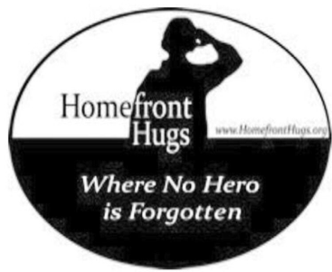

Operation Healing Angel of Homefront Hugs Foundation

Many thanks for your interest in lifting the spirits of our sick and wounded veterans and their hero medical staff.
This is what is needed for Operation Healing Angel - another fun volunteer project for any age!

🔹handwritten cards and letters to medical staff and veterans sharing a little about yourself and any get well wishes and thanks
🔹art work to hang at nursing stations, patient rooms and patient activity areas

Additional items to send if you choose:
🔹nerf soft footballs
🔹battery operated strings of light to decorate rooms
🔹decorated pillow cases: Operation Pillow Hugs (under forms)
🔹dry erase board with dry erase markers
🔹flameless candles with batteries
🔹adult coloring books with colored pencils
🔹hand lotion for staff and patients
🔹lip balm for patients and staff
🔹u shaped travel neck pillows for patients
🔹calendars for the new year are always welcome with positive message ,aviation, cars, boating , pets and scenic US landscapes even handmade calendars!

Any of the above will be appreciated but most of all the cards and artwork are appreciated anytime of year. Deadline for the winter holidays is December 5th but we do collect for the New Year until early January.

You can send your letters and treats or an appreciated monetary donation to our charity to help with cost of mailing and delivering OHA care packages:

Homefront Hugs Foundation
Operation Healing Angel (OHA)
314 Goodmans Xing
Clark, NJ 07066

Please make certain you clearly mark on each card/letter/artwork for
whom card and letter was written or created :
“ for a physician , nurse ,medic ,tech ,chaplain,
Sick veteran ,wounded veteran “

Students under age 18 should just sign with first name, age and city for security. Please let us know what your plans are so we can let the hospitals know and please share some photos of your volunteers preparing their surprises or writing their letters if possible. We welcome these via e-mail to HomefrontHugsUSA@aol.com or OHA@HomefrontHugs.org.

